Dates: August 6 – August 12, 2018
Weekend Breakfast: Served 6:30am to 10am:

Sausage Gravy

Buttermilk Biscuits

Bacon Strips

Sausage Patties

Tater Rounds

Saturday Specials: Breakfast Casserole
Sunday Specials: Breakfast Sandwiches

Bakery Case: Muffins, Cookies, Assorted Dessert Bars
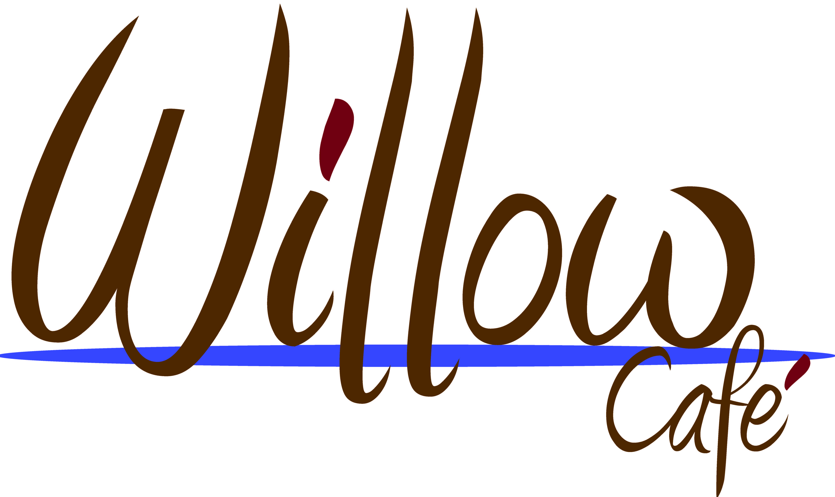
Weekday Breakfast: Served 6:30am to 10am

Sausage Gravy

Buttermilk Biscuits

Bacon Strips

Sausage Patties

Tater Rounds

Custom Eggs (Scrambled/Fried) and Omelets

Bakery Case: Assorted Muffins, Donuts, Cookies, Bars

Open 6:30am to 6pm Monday thru Friday; 6:30am to 2pm on Saturday, Sunday, and holidays
Breakfast: 6:30am to 10am
Lunch: 11am to 2pm
Dinner: 4:30pm to 6pm
Beverages, snacks, and grab ‘n go items available all day

Monday | Tuesday | Wednesday | Thursday | Friday | Saturday | Sunday
Lunch Specials: | Lunch Specials: | Lunch Specials: | Lunch Specials: | Lunch Specials: | Lunch available until 2pm | Lunch available until 2pm
Chicken Queso Nachos  Grilled Chicken, , Tomatoes, Black Olive, Jalapeno Peppers, Salsa, Sour Cream With Fresh Basil Over A Layer Of Tortilla Chips  Baked Lemon Herb Cod  Broccoli Rice Casserole  Roasted Zucchini With Parmesan  Lyonniase Carrots  Chef’s Choice Dessert  Custom Salad Bar Thru Lunch | Coney Dog on Bun  Spaghetti  Garlic Bread  Mashed Potatoes  Seasoned Sauerkraut  Seasoned Green Beans  Homemade Bacon Broccoli Cauliflower Salad  Custom Salad Bar Through Lunch | “BREAKFAST SPECIAL”  6:30A – 10A  HOMEMADE CHEESE STRATA  Stir Fried Chicken and Refried Rice Served With a Egg Roll  Homemade Salmon Patties/W  Cheese Sauce  Roasted Mini Potatoes  Creamed Peas  Roasted Stir Fry Veggies  Custom Salad Bar through lunch | Soup and Sandwich Combo  Choice of Creamy Broccoli or Rst Red Tomato Soup with a Turkey Club on a Sub Bun  Smothered Chicken  Wild Rice  Roasted California Blend Veggies  Indiana Succotash  Custom Salad Bar through lunch | Taco Salad  Blackened Salmon  Homemade Noodles Romanoff  Chef’s Choice Veggie Stir Medley  Broccoli Florets  Custom Salad Bar through lunch | “NEW ITEM”  Corn Dog  Mozzarella Cheese Sticks/W  Marinara Sauce  Assorted Side Salads and Desserts  Willow Café  closes at 2pm;  reopens at 6:30am | Beef Manhattan  Beef Gravy  Mashed Potatoes  Seasoned Green Beans  Willow Café  closes at 2pm;  reopens at 6:30am
Dinner Specials: | Dinner Specials: | Dinner Specials: | Dinner Specials: | Dinner Specials:
Chicken Queso Nachos | Spaghetti  Garlic Bread | Salmon Patty/W Cheese Sauce  Creamed Peas | Chefs Choice Soup  Turkey Club | Taco Salad

Daily Grill Items (available during Lunch and Dinner):

Chicken Tenders, Grilled/Breaded Chicken Breast

Hamburger/Cheeseburger

Breaded Scrod (Whitefish)

Grilled Cheese Sandwich

French Fries
Daily Grab ‘n Go Items (items vary daily):
Sandwiches, Wraps, Salads

Fruits

Dessert Bars, Cookies

Ritters Frozen Custard

