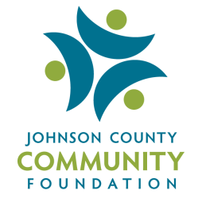

Youth Philanthropy Initiate of Johnson County
Board Application

Name:
Address:
City: | State: |  | Zip:
Age: |  | Student Phone Number:
School System: |  | Student Email:
List of current activities (church, clubs, school, etc) and leadership roles:
What talents or experience do you believe you can bring to the YPIJC Board:
Signature:

To submit please email a copy of this form saved as YPIJC Board Application to Leeannh@jccf.org.

