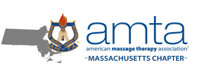

May 25, 2020

Mr. Mike Kennealy, Secretary
Massachusetts Executive Office of Housing and Economic Development
One Ashburton Place, Room 2101
Boston, Massachusetts 02108

Ms. Monica Bharel, Commissioner
Massachusetts Department of Public Health
250 Washington Street
Boston, Massachusetts 02108

RE: Sector Guidance - Massage Therapy Profession

Dear Secretary Kennealy and Commissioner Bharel:

On behalf of the approximately 3,000 members of the Massachusetts Chapter of the American Massage Therapy Association (“AMTA-MA”), I write to offer input into the development of Sector specific guidance for massage therapists by your agencies. In particular, the AMTA-MA encourages you to adopt a nationally recognized standard while noting three specific considerations that will impact the creation of any Sector specific guidance for massage therapy.

As you may know, the Federation of State Massage Therapy Boards (“FSMTB”) is an autonomous, not-for-profit organization comprised of state regulatory boards and agencies that regulate the massage therapy profession. The Massachusetts Board of Registration for Massage Therapy (“Board”) is a member of the FSMTB. On May 19, 2020, the FSMTB released the attached “Guidelines for Practice with COVID-19 Considerations” (See also, https://www.fsmtb.org/media/2319/fsmtb20200519guidelinesforpracticecovid-19.pdf. This document, which was peer reviewed by the American Massage Therapy Association and Associated Bodywork and Massage Professionals (“ABMP”), contains recommendations and guidelines for massage and bodywork practitioners to mitigate the spread of COVID-19. According to the document, “[t]he intent of this document is to provide a resource to FSMTB Member Boards and Agencies, massage and bodywork professionals, and massage school staff in order to support public protection.”. In an effort to protect practitioners and clients, while ensuring a uniformity of standards, the AMTA-MA respectfully urges your agencies to adopt the FSMTB standards as the Sector specific guidance for massage therapy within the Commonwealth. While there are certain areas the AMTA-MA highlights below for additional consideration, the FSMTB guidance document provides a reasonable outline for practicing massage therapy in light of COVID-19.

Regardless of whether the Commonwealth adopts the FSMTB guidance document in part or whole, the AMTA-MA would like to highlight three areas that any Sector specific guidance for massage therapy must consider. To that end, please ensure that any Sector specific guidance for massage therapy recognize the following:-

- Massage therapy is provided in a variety of settings. Massage therapy does not solely occur in the traditional office or retail setting. Massage therapy is offered within home office locations, traditional retail space, hospitals, health care providers’ offices and many other locations. In developing any Sector specific guidance for massage therapists, please recognize that “one size does not fit all”. If a requirement cannot be met due to a physical impossibility that is otherwise acceptable under existing laws and regulations governing massage therapy in the Commonwealth, please allow for such variance. (i.e. requiring sinks within “X” feet of massage room where current regulations may allow for “Y” feet.). The massage therapy profession already maintains a high standard for hygiene and cleanliness; any additional requirements related to the areas in which massage are provided should complement existing requirements not compete against them.

- Personal Protective Equipment (“PPE”). One of the significant concerns for massage therapists will be the practice and financial implications for requiring PPE at all times. As stated by the FSMTB in the aforementioned guidance document, “[i]n response to COVID-19, massage practitioners are advised to use face masks and protective clothing. Gloves are worn to handle potentially contaminated linens and when discontinuous skin, blood, or body fluid is present.”. The key behind this guidance is the recognition that face masks and protective clothing are appropriate at all times and that gloves are necessary in certain circumstances. Finally, any PPE requirements should ensure that massage therapists, who are often small businesses or sole proprietors, have reasonable access to affordable PPE, if so mandated.

- Client In-Take Processes and Procedures. Perhaps one of the most important elements to preventing the potential spread of COVID-19 will be the modification and addition of certain client in-take processes and procedures. Staggering appointment times, removing non-essential “common touch” items (i.e. decluttering) and new “waiting” procedures are among some of the practices that will need to change. Again, the guidance provided in the FSMTB’s guidance document is on point. However, one client in-take measure, also addressed in the FSMTB document, should be highlighted – the client screening. Asking a potential client a series of COVID-19 exposure questions will protect the massage therapist, the specific client and other potential clients. Whether making the massage therapist aware of potential contraindications (i.e. an asymptomatic individual with potential coagulation abnormalities) or assisting the massage therapist in deciding whether to provide services at all, the client screening procedures take on a heightened importance. As is already provided in regulations governing massage therapy, it should be underscored that massage therapists maintain “the right to refuse to treat any person in order to protect the mental, physical, emotional and professional boundaries and safety of the practitioner.” (269 CMR 5.01(11).)

The AMTA-MA looks forward to the opportunity of working with your agencies to ensure that the massage therapy profession reopens in a manner that supports the needs of practitioners and clients while balancing the overarching concerns for public health in light of COVID-19. Again, evidence continues to build, showing massage therapy as effective treatment of many common health complaints, including, but not limited to, anxiety and depression, post-operative recovery, headache, neck and shoulder pain, low back pain, athletic injury and post-exercise recovery. One of the fastest growing health care professions, massage therapy is increasingly viewed as part of integrative health care. With the issuance of Sector specific guidance for massage therapists, we look forward to continuing our work.

On behalf of the approximately 3,000 massage therapists of the AMTA-MA, I look forward to the opportunity of discussing this matter with you in more detail soon. If you have any questions or concerns, please do not hesitate to contact me.

Sincerely,
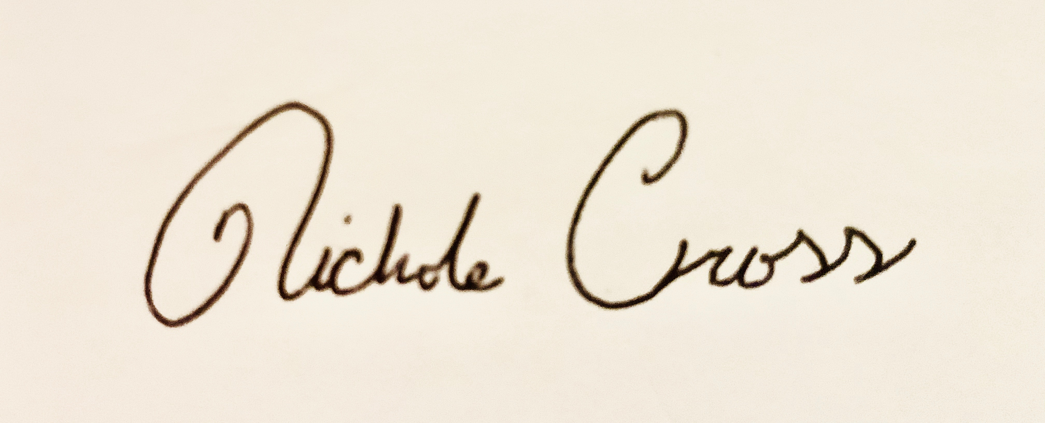
Nichole Cross
President
Cc:

Ms. Layla D’Emilia, Commissioner
Massachusetts Division of Professional Licensure

