Great Lakes Athletic Trainers’ Association

51st Annual Meeting and Symposium

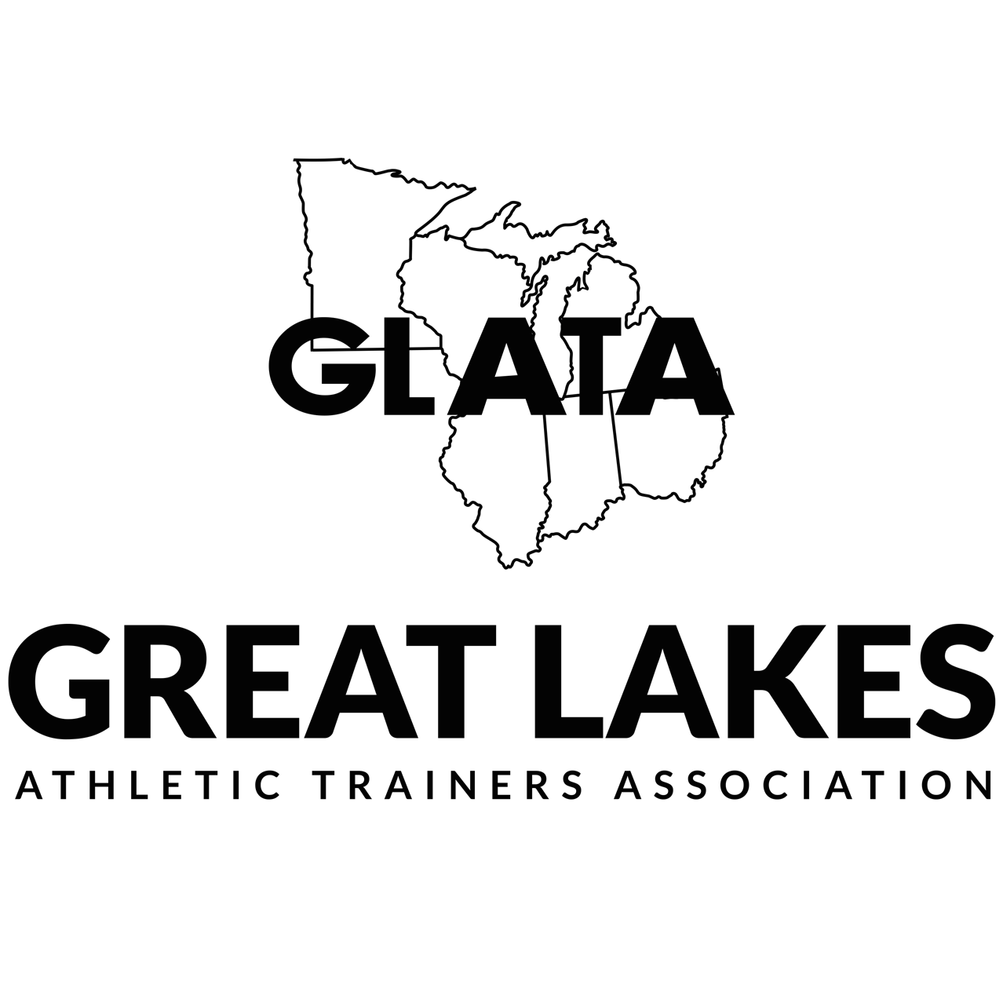
March 13th, 14th, 15th, & 16th, 2019

The Westin Chicago North Shore

Wheeling, IL
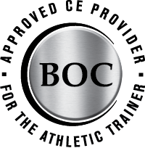
11 CEUs & 10 EBP CEUs

“GLATA is approved by the Board of Certification, Inc.
to offer continuing education for Certified Athletic Trainers.”

*Continuing Education Units’ Statement of Credit
will be distributed within 30 days following the meeting*

Registration Hours – Sponsored by ATHLETICO
Ravinia Ballroom Pre-Function Area
Wed, March 13th 1:00pm – 5:00pm
Thurs, March 14th 8:00am – 3:30pm
Fri, March 15th 7:00am – 12:00pm

Exhibit Hours
Fri, March 15th 8:30am – 10:30am (Certified Only)
10:30am – 1:30pm (All Attendees)

Committee Meetings
Executive Committee
Wed, March 13th 7:30am – 6:00pm – Lake Michigan A

GLATA Student Senate
Wed, March 13th 1:00pm – 5:00pm – Elm Room
Thurs, March 14th 7:30am – 11:00am – Elm Room
Sat, March 16th 12:00pm – 4:00pm – Elm Room

Critical Incident Stress Management (CISM)
Thurs, March 14th 7:30am – 9:00am – Birch Room

Committee on Practice Advancement (COPA)
Thurs, March 14th 1:00 – 2:00pm – Elm Room

Secondary School Athletic Trainer Committee
Thurs, March 14th 3:00pm – 4:00pm – Elm Room

Governmental Affairs
Fri, March 15th 10:30am – 11:30pm – Birch Room

Research Committee
Fri, March 15th 2:00pm – 3:00pm – Birch Room

GLATA Conference Meeting area has FREE Wi-Fi – Network name - TBD

(SP) – Student Program – This symbol indicates programming planned by the GLATA Student Senate to be of particular interest to students.

No individual should be denied participation in CE programs offered by the GLATA on the basis of race, color, national origin, religion, sex, disability, military status, sexual orientation or age.

Mini Courses

Tuesday, March 12th & Wednesday, March 13th
Mini Course A Graston Technique M1-Basic Training
3/12, 12:30pm – 9:00pm Chris Vernon, MEd, MBA, ATC, PES, GTS
3/13, 8:00am – 3:00pm Mike Ploski, PT, ATC, OCS, GS
12 CEU’s
Birch Room

Wednesday, March 13th
Mini Course B Positional Release Therapy: An Evidenced Based Review
3:00pm – 9:00pm Timothy Speicher, PhD, ATC, CSCS, PRT-c
6 EBP CEUs
Ravinia Ballroom A

Mini Course C Putting it All Together: Low Frequency with High Fidelity Skills
5:00pm – 9:00pm Darryl Conway, MA, ATC
4 CEUs Edward Strapp, FP-C, NRP, ATC
Ravinia Ballroom B

Mini Course D Hydration: One Size Does Not Fit All
4:00pm – 6:30pm Lindsay Baker
2.5 CEUs Douglas Casa, PhD, ATC, FNATA, FACSM, FNAK
Birch Room George Chiampas

Mini Course E Phlebotomy 101: A How-To Guide for Drawing Blood
7:00pm – 9:00pm Andrea Cripps, PhD, ATC
2 CEUs
Birch Room

Thursday, March 14th
Mini Course F HealthCare Provider CPR
6:30pm – 9:30pm American Heart Association CPR-PR Recertification - Healthcare Provider
NO CEUs Matthew Marzullo, MEd, ATC
Botanic Ballroom Steve Mayo, MS, ATC

Mini Course G Functional Casting Therapy - Upper Extremity
6:30pm – 9:00pm Katherine Bagnato, ATC, OTC, CEAS
2.5 CEUs
Birch Room

Saturday, March 16th
Mini Course H Advancing Athletic Training Skills: Wound Closure
9:00am – 11:00am Elizabeth Neil, MS, ATC
2 EBP CEUs Douglas Stevens, BS, MMS, PA-C
Birch Room

Mini Course I Point of Care Ultrasound: Cutting edge care of the athlete
11:00am – 1:00pm James Daniels, MD, MPH
2 CEUs Erica Miller-Spears, MS, PA-C, ATC, RMSK
Birch Room

General Program

Thursday, March 14th
8:30am – 10:00am Common Skin Infections and Conditions in Athletic Populations SP
Ryan Musgrave, MS, ATC
River Ballroom

9:00am – 10:00am Athletic Trainer's Response to the Opioid Crisis:
A Comprehensive 360 Degree Approach
Darryl Conway, MA, ATC
Edward Strapp, FP-C, NRP, ATC
Ravina Ballroom ABC

Clinical Skills Lab – Primer
Robert “BC” Charles-Liscombe, EdD, ATC
Jennifer K. Popp, PhD, ATC
Lake Michigan Ballroom

What’s New with Shoulder Replacement in 2019: from Resurfacing to Reverse
Thomas Obermeyer, MD
Botanic Ballroom

10:00am – 6:00pm Skills Practice
Robert “BC” Charles-Liscombe, EdD, ATC
Jennifer K. Popp, PhD, ATC
Skills stations available for practice, refinement and continuing education.
      - Heat Illness - Using a task trainer, clinicians will be able to assess their knowledge and ability and practice the skills needed to assess core body temperature by inserting a flexible probe rectal thermometer necessary for ice immersion treatment and rapid reading semi-rigid thermometer.
      - Heart and Lung Sounds - Using a mannequin and vital signs simulator, clinicians will be able to assess their knowledge and ability and practice the skills needed to detect normal and abnormal sounds using a stethoscope.
      - Eye, Ear, Nose and Throat Physical Examination - Using task trainers and lab assistants, clinicians will be able to assess their knowledge and ability and practice the skills needed to conduct a physical examination of the eye, the ear, nose and throat using high and low cost opthalmoscope/otoscope tools.
      - Basic Life Support - Using task trainers, clinicians will be able to assess their knowledge and ability to establish an airway using OPA, NPA, and supraglottal airway adjuncts; administer supplemental oxygen via cannula, non-rebreather masks, and bag valve masks; and provide chest compressions at the recommended rate and depth.
      - Managing Hemorrhage - Tourniquets, hemostatic agents, and suture practice pads.
Lab assistants will be available to guide participants in self-directed skills practice, multi-media resources will be available for review and instruction, and cost estimates and vendor supplies lists will be available for participants to support purchasing decisions for AT clinical settings.
Willow Room

10:00am – 1:00pm GLATA Oral Free Communication Session
Free Communications provide highly structured and efficient presentations regarding the most current original research (clinical, survey, qualitative, meta-analysis/systematic reviews) and clinical case reports. Each Free Communication is 15-minutes (10-minutes presentation, 5-minutes Q&A), which concludes with clinical/practical application. Professional oral presentations and student poster presentations are intermingled.
Moderator: Christopher Kuenze PhD, ATC
Botanic Ballroom *GLATA Research Assistance Award Winner

10:00am – 1:00pm Leadership Development
Trevor Bates, DHSc, ATC
Darryl Conway, MA, ATC
Matt Kutz, PhD, ATC
Birch Ballroom

10:00am – 11:00am EBP - Identification of Throwing Pathomechanics and Their
Anatomical Origins: An Evidence
Aaron Struminger, PhD, ATC
Ravinia Ballroom ABC

Arthrofibrosis: An Evidence-Based Approach To Management SP
Scott Lawrance, DHSc, ATC, MSPT, CSCS
River Ballroom

11:00am – 12:00pm Appearance and Performance Enhancing Substances: The Pressure to Perform
Brian Parker
Ravinia Ballroom ABC

Practice-Based Research in Athletic Training
Cameron Powden, PhD, ATC
Matthew Rivera, DAT ATC
Lake Michigan Ballroom

The Who, What, and Why of Sports Specialization SP
David Bell, PhD, ATC
River Ballroom

12:00pm – 1:00pm Return-To-Learn Following Concussion - Across Settings
Justin Tatman, MA, ATC
Brian Vesci, DAT, ATC
Ravinia Ballroom ABC

Implementing Clinical Outcomes Assessments In Collegiate Athleticcs:
Overview And Practical Examples
Michael Moll, PhD, ATC
Grant E. Norte, PhD, ATC, CSCS
Lake Michigan Ballroom

Student Luncheon (Students Only)
River Ballroom

1:00pm – 2:00pm EBP - Articular Cartilage Injuries of the Knee:
Evidence for Rehabilitation and Return-to-Sport
Jenny Toonstra, PhD, ATC
Ravinia Ballroom ABC

Menstrual Dysfunction Screening for All Female Athletes SP
Julie Young, MA, ATC, PES
Lake Michigan Ballroom

NCAA Mental Health SP
John Parsons, PhD, ATC
Botanic Ballroom

2:00pm – 3:00pm Emerging Evidence for the Role of Instrument -
Assisted Soft Tissue Mobilization in the Treatment of Tendinopathy
Mike Ploski, PT, ATC, OCS, GS
Ravinia Ballroom ABC

CAATE Update:
LesLee Taylor, PhD, ATC
Lake Michigan Ballroom

The Integrative Sports Medicine Model
Candice Dunkin, MS, ATC
Ashley Emerson, ATC
Botanic Ballroom

2:00pm – 3:30pm Student Panel Career Roundtable SP
River Ballroom

3:30pm – 5:00pm GLATA Student AT Olympics SP
Scott Lawrance, DHSc, ATC, MSPT, CSCS
River Ballroom

3:00pm – 4:00pm Building a Diabetes High Performance Team
John Mucovich, MA, ATC
Christina Weidman, RDN, CSSD, LDN
Ravinia Ballroom ABC

Life after sport: Your role in preparing athletes to transition well
Lauren Link, RD, CSSD
Alice Wilcoxson, PhD, ATC, PT
Lake Michigan Ballroom

So You're Saying an AT Can Do That
Tim Drudge, MS, ATC
Botanic Ballroom

From Conception To Dissemination: The Life Cycle Of An Article
David Berry, PhD, ATC
Matt Kutz, PhD, ATC
William Pitney, EdD, ATC, FNATA
Birch Room
4:00pm – 5:00pm EBP - Interventions to Enhance Disease-Oriented and Patient-Oriented Impairments in Those with Chronic Ankle Instability
Matthew Hoch, PhD, ATC
Cameron Powden, PhD, ATC
Ravinia Ballroom ABC

5:00pm – 6:30pm GLATA BUSINESS MEETING
Ravinia Ballroom ABC

7:00pm – 9:00pm It's all in the Hips: Demystifying Hip-Lumbo-Pelvic Alignment and Correction
Andrew Doyle, PhD, ATC, CSCS
Lake Michigan Ballroom

Friday, March 15th
7:30am – 8:30am STATE MEETINGS
Illinois Ravinia Ballroom ABC
Indiana Lake Michigan Ballroom
Michigan Botanic Ballroom
Minnesota River Ballroom
Ohio Birch Room
Wisconsin Elm Room

8:30am – 2:00pm EXHIBIT HALL OPENS
Ravinia Ballroom DEF

8:30am – 10:00am Preventing Sudden Death SP
Douglas Case, PhD, ATC, FNATA, FACSM, FNAK
River Ballroom

8:30am – 9:30am EBP - Medial Tibial Stress Syndrome: So Much More Than "Shin Splints"
Taylor Arman, MSEd, ATC
Aleksandra Stasaitis, MS, ATC
Ravinia Ballroom ABC

9:30am – 10:30am Strategic Issues in Athletic Training Lecture Series: Transition to Practice
Brian Vesci, ADAT, ATC
Ravina Ballroom ABC

Ethical Principles for the Athletic Trainer
Darryl Conway, MA, ATC
Timothy Neal, MS, ATC, CCISM
Lake Michigan Ballroom

Facilitating Effective Debriefing with Clinicians to Improve Patient Care
Kirk Armstrong, EdD, ATC
Birch Room

9:30am – 11:30pm GLATA Oral Free Communication Session
Free Communications provide highly structured and efficient presentations regarding the most current original research (clinical, survey, qualitative, meta-analysis/systematic reviews) and clinical case reports. Each Free Communication is 15-minutes (10-minutes presentation, 5-minutes Q&A), which concludes with clinical/practical application. Professional oral presentations and student poster presentations are intermingled.
Moderator: Lisa S. Jutte, PhD, ATC
Botanic Ballroom *GLATA Research Assistance Award Winner

10:00am – 11:00am Why Administration Matters SP
Elizabeth Neal, MS, ATC
Zachary Winkelmann, MS, ATC
River Ballroom

10:30am – 11:30pm The KSI State Rankings of Health and Safety Policies for High School Athletes
Douglas Casa, PhD, ATC, FNATA, FACSM, FNAK
Ravina Ballroom ABC

Third Party Reimbursement for Services Provided by Athletic Trainers in the Collegiate Setting
Clark Simpson, MBA, MEd, RKT, ATC
Lake Michigan Ballroom

11:00am – 12:00pm Non-Surgical Management of Hammertoe SP
David Craig, ATC
River Ballroom

11:30pm – 12:30pm Exhibit Break/Poster Session
Non- Certified Poster Presentations
Botanic Ballroom Pre-Function area

12:30pm – 1:30pm Best Practices of Appropriate Medical Care in Secondary Schools
Larry Cooper, MS, ATC
Bart Peterson, MSS, ATC
Ravinia Ballroom ABC

Utilizing Technology to Improve Quality Improvement
Lindsey Eberman, PhD, ATC
Elizabeth Neal, MS, ATC
Lake Michigan Ballroom

Transition to Practice 101: SP
How to Get a Real Job without any "Real" Experience
Trevor Bates, DHSc, ATC
Matt Kutz, PhD, ATC
Botanic Ballroom

1:30pm – 2:30pm EBP - Let's get to the point: Therapeutic Dry Needling
Jill Thein-Nissenbaum, PT, DSc, SCS, ATC
Ravinia Ballroom ABC

1:30pm – 3:30pm GLATA Quiz Bowl
River Ballroom

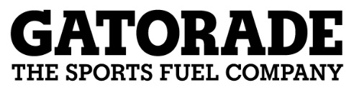
2:30pm – 3:30pm EBP - The Hydration Debate:
Making Sense of the Mixed Messages
Sponsored by Gatorade
Robert Kenesick
Ravinia Ballroom ABC

3:30pm – 5:00pm Pinky Newell Talk - Creating the New Normal
John Register
Ravinia Ballroom ABC

GLATA Awards Presentation
Ravina Ballroom ABC

6:00pm – 8:00pm NATAPAC Fundraiser
Ravinia Ballroom DEF

8:00pm – 11:00pm GLATA Social
Ravinia Ballroom DEF

Saturday, March 16th
8:00am – 9:00am Incidence and Injury Rates in Pre-Collegiate Female Gymnasts
Sharon Frank, MS, ATC
Lake Michigan Ballroom

Psychosocial and Environmental Barriers To Functional Recovery after Knee Injury
Chris Kuenze, PhD, ATC
Caroline Lisee, Med, ATC
Botanic Ballroom

9:00am – 10:30am Foundational Concepts of Joint Mobilization for the Athletic Trainer SP
Jessica Keller, DAT, ATC
Adam Thompson, PhD, ATC
River Ballroom

9:00am – 11:00am EBP – Neural Complications of Common Upper Extremity Orthopedic Injuries
Jill Murphy, DPT, ATC, CSCS
Lake Michigan Ballroom

EBP – Advanced Topics in Manual Therapy
Eric Schneider, PT, MPT, OCS
Botanic Ballroom

10:30am – 12:00pm Immobilization Techniques in The Prehospital Setting: SP
Moving Beyond the Basic Rigid Splint
David Berry, PhD, ATC
Darryl Conway, MA, ATC
River Ballroom

11:00am – 1:00pm EBP - Getting the most bang for your exercise buck:
Which exercises best activate the scapular muscles
Alyson Kelsey, MEd, ATC
Jill Thein-Nissenbaum, PT, DSc, SCS, ATC
Lake Michigan Ballroom

Treating Lumbar And Thoracic Spine Mobility Deficits
Using Muscle Energy Techniques
Scott Lawrance, DHSc, ATC, MSPT, CSCS
Botanic Ballroom

Call for Presentation Proposals for the 2020 GLATA Annual Meeting and Symposium
March 11-14, 2020
Wheeling, IL

The Great Lakes Athletic Trainers’ Association Education Committee is inviting proposals for professional presentations at the 2020 Annual Meeting and Symposium in Wheeling, IL, March 11-14, 2019. Athletic Trainers and affiliated professionals are encouraged to submit proposals for both general sessions and those that may qualify for the BOC’s Evidence-based Practice (EBP) continuing education units (CEUs). Presentation formats for all sessions include: feature presentations, learning labs and mini-courses. Further descriptions and guidelines for both types of proposals are posted on the GLATA website under the Annual Meeting tab.

Presentation topics should address athletic training domain(s) beyond entry-level knowledge or address a topic that would make a valuable contribution to the understanding of the practice or pedagogy of athletic training. EBP foundational presentations should enhance the athletic trainer’s understanding and implementation of EBP, while EBP clinical presentation should address the presentation topic using the best available evidence. In addition, if one’s EBP presentation proposal is accepted by the GLATA, the author(s) must work with the GLATA Education Committee in securing BOC EBP course approval.

Individuals interested in presenting must complete the online application indicating the presentation type, learning objectives, and resources needed as well as a structured abstract (250 word limit; see website for format). Please note there is a specific application and proposal format for an EBP presentation. All proposals must be submitted electronically through the GLATA website [www.glata.org]. Mailed or faxed submissions will not be considered. Please contact Jessica Emlich Jochum, GLATA Education Committee Chair (jochumj@uindy.edu) regarding any questions. Each submission will undergo review by the GLATA Education Committee.

Submissions must be received by May 1, 2019 for consideration.

 | Length | # of Speakers | Format
Feature Presentation | 1 hr | 1-2 Speakers | Lecture only
Learning Lab | 2 hrs total | 1-2 Speakers + lab assistants | Lecture and lab combination
Mini-Courses | 2-6 hrs pre/post conference (attendees register for additional  CEUs) | 1-2 Speakers + lab assistants | Speaker’s choice of lecture, lab or combination

Great Lakes Athletic Trainers’ Association
2018 Award Winners

Golden Pinnacle
TBD
Outstanding Educator Award
TBD

Dedicated Service Award
TBD
President’s Excellence Award
TBD

Gatorade Secondary School Athletic Trainer Award
TBD

GLATA Student Senate Preceptor of the Year
TBD

Fall 2018 Research Award Recipients - Bob Behnke Research Assistance Award
TBD

Spring 2018 Research Award Recipients - Gordy Graham Research Assistance Award
TBD

Thomas Weidner Research Assistance Award
TBD

Public Relations Contest Winner
TBD

GLATA Award Winners: 2002 – 2018

Honorary Membership:

Elizabeth Arendt
Lou Belch
John Bergfeld
Gary Calabrese
Michael Collins
Gerry Detty
Joe Eagan
Scott Euype
David Fisher
Peter Hovorka
Beverly Knight
Brian Matix
Richard Parker
Paul Strandquist
Kenneth Zisholz

Outstanding Educator:

Gerald W. Bell
David Berry
Rebekah Bower
David Carrier
Lorin Cartwright
George Davies
Carrie Docherty
Lindsey Eberman
Jessica Emlich
Katie Grove
Laura L. Harris
Dorice Hankemeier
Brian Hatzel
Christopher Ingersoll
Scott Lawrance
Christine A. Lauber
Larry Leverenz
Malissa Martin
Heidi Matthews
Mark Merrick
Michael Miller
Sally Nogle
Jeff Oliphant
Kim Peer
William A. Pitney
Jennifer Popp
John Powell
Richard Ray
Gretchen Schlabach
John W. Schrader
Patrick Sexton
Renee’ Revis Shingles
Craig Voll
Stacy Walker
Jessica Wallace
Thomas G. Weidner
Andrew Winterstein
Alice Wilcoxson
Ryan Wilkinson

Dedicated Service:

Gerald W. Bell
Ann Berry
Dale Burkhouse
Dan Campbell
Lorin Cartwright
Jessica Emlich
Christina Eyers
Kevin Gerlach
Mark Gibson
Katie Grove
Robert S. Gray
Chris Huot
Roger Kalisiak
Lisa Kluchurosky
Hollie Kozak
Gary Lake
Jan Lauer
Scott Lawrance
Larry Leverenz
Tory Lindley
Matt Marzullo
Michael Medich
Justin Miller
Brent Millikin
James Moore
Kari Odland
Allen Passerallo
Angela Perusek
Jill Ponzi
Dan Rasor
Richard Ray
Gary D. Reinholtz
Steve Risinger
Julie Rochester
Mark Schauer
Gretchen Schlabach
Lisa Schoene
Patrick J. Sexton
Brad Sherman
Renee’ Revis Shingles
Megan Streveler
Mark Stoessner
William Sullivan
Wayne Vaupel
Marion Vruggink
Craig Voll
Kerry Waple
Tom Weidner

Golden Pinnacle:

Marjorie Albohm
Robert S. Behnke
Gerald Bell
Ann Berry
Cynthia Booth
Lorin Cartwright
David Craig
Kent Falb
Tony Garofalo
Kevin Gerlach
Mark Gibson
Dale Googins
Gordon Graham
Robert Gray
Catherine Grove
William Hughes
Carol Humble
Roger A. Kalisiak
Gary Lake
Jan Lauer
Tory Lindley
Dennis A. Miller
Rod Moore
Paul Plummer
Richard Ray
Julie Rochester
John W. Schrader
Rick Shaw
Kip Smith
William Tessendorf
Marion Vruggink
Craig Voll
Jerry Whetstone
Westin Hotel Floor Plan
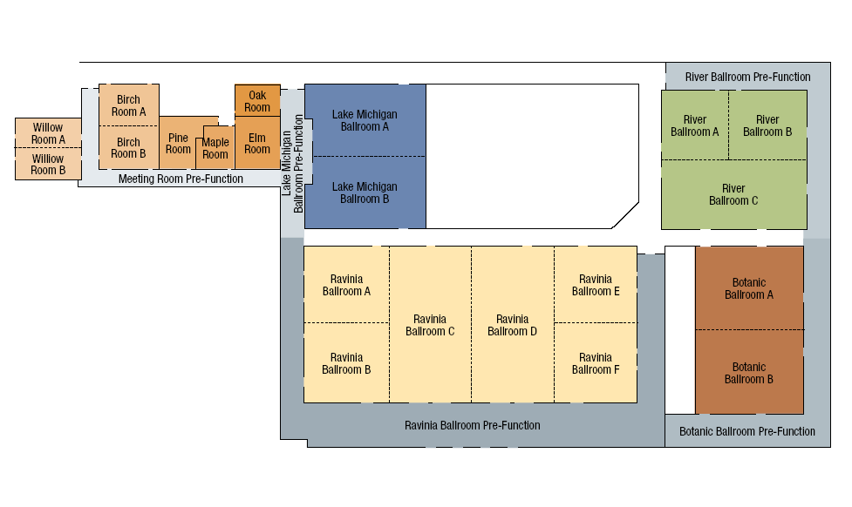
Maple
Room
Oak
Room

GLATA Future Meetings
March 11-14, 2020 - The Westin Chicago North Shore
March 10-13, 2021 - The Westin Chicago North Shore
March 9-12, 2022 - The Westin Chicago North Shore

